

**Internship Report**

## **Real-Time Twitter Analytics Dashboard - Power BI**

## **Name: Ritika Bhardwaj Internship Period: 07-12-2024 to 07-04-2025 (4 Months) Company Name: NULLCLASS**

# 1. Introduction

**The internship at NullClass was an enriching experience that provided hands-on exposure Data Analytics.**

**This report summarizes my internship project focused on analyzing Twitter engagement data using Power BI. The goal was to develop interactive dashboards with time-based restrictions to visualize tweet performance metrics such as engagement rates, clicks, and media interactions.**

# 2. Background

**Twitter (now X) is a major social media platform where engagement metrics (likes, retweets, clicks) determine content success. This project analyzed a dataset to identify high-performing content based on:**

* + **Engagement rates**
  + **Click-through rates (URL, profile, hashtag clicks)**
  + **Media interactions (views & engagements)**

**Tools Used:**

* + **Power BI (Data modeling, DAX, visualization)**
  + **Power Query (Data transformation)**

# 3. Learning Objectives

* **Develop time-sensitive dashboards**
* **Implement dynamic filtering (tweet length, date parity)**
* **Master DAX measures (percentiles, conditional aggregations)**
* **Create interactive drill-down reports**

# 4. Activities and Tasks

#### 4.1 Data Preparation

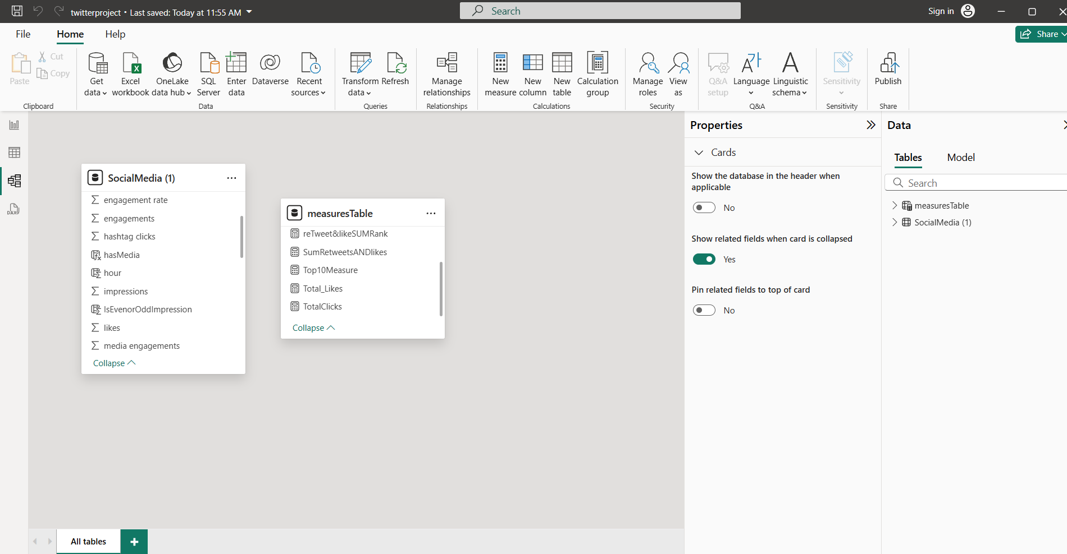

**Created calculated columns:**

**Example-**

**IsEvenorOddImpression = IF(MOD('SocialMedia (1)'[impressions], 2) = 0, 1, 0)**

### 4.2 DAX Measures

**Created several maeasures:**

**AboveMedianMediaMeasure =**

**VAR MedianValue = MEDIANX(ALL('SocialMedia (1)'), 'SocialMedia (1)'[media engagements])**

**RETURN**

**IF(**

**SUM ('SocialMedia (1)'[media engagements]) > MedianValue,**

**1,**

**0**

**)**

### 4.3 Dashboard Development

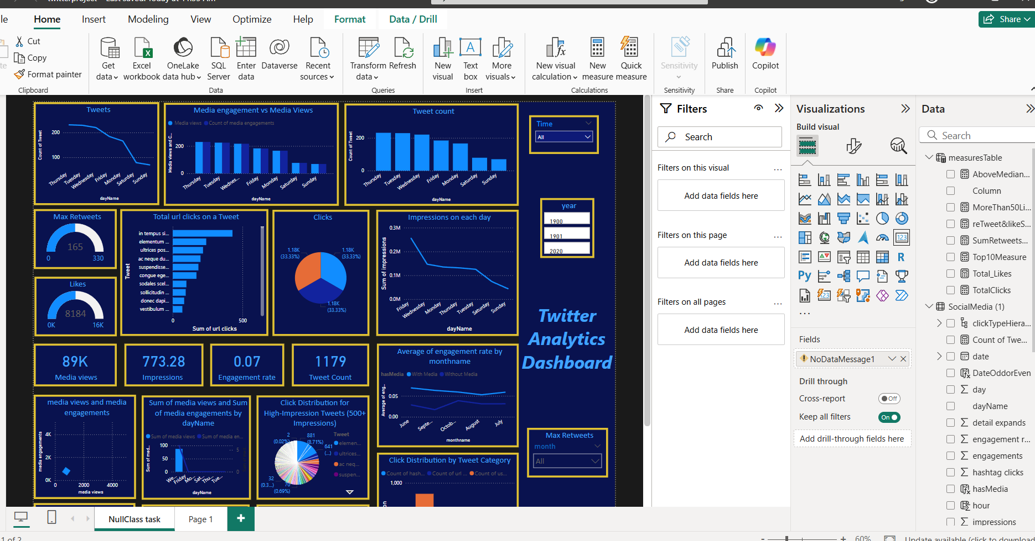

# 5. Skills and Competencies

**Technical Skills:**

* **Power BI (DAX, bookmarks, data modeling)**
* **Dynamic visualizations (drill-down, tooltips)**

**Analytical Skills:**

* **Identified high-performing tweets using percentile analysis**
* **Compared engagement trends with/without media**

**Problem-Solving:**

* **Resolved time-zone issues in visibility logic**
* **Optimized DAX performance**

# 6. Challenges and Solutions

|  |  |
| --- | --- |
| **Challenge** | **Solution** |
| **Time-based visibility** | **Used UTCNOW() + IST offset** |
| **Large dataset performance** | **Optimized DAX with FILTER()** |
| **Dynamic word filtering** | **Created SUBSTITUTE()-based measures** |

# 7. Outcomes and Impact

**Deliverables:**

* **9 interactive Power BI Visuals**
* **Documentation of DAX logic**

**Impact:**

* **Identified top 10% engagement tweets**
* **Revealed peak interaction time (3PM–5PM IST)**

# 8. Conclusion

**This project enhanced my Power BI expertise in DAX and dynamic reporting. Future improvements could include real-time data streaming and sentiment analysis integration.**